**To Supply Leftover Food to the Poor**

|  |  |
| --- | --- |
| **College Name :**  **College Code :** | Anna University Regional Campus, Coimbatore  7100 |
| **Team Leader :**  **NM ID :**  **Register No :** | Ashni P K  auttrcse006  710021104712 |
| **Member 1 :**  **NM ID :**  **Register No :** | Ashwanthini R  auttrcse003  710021104710 |
| **Member 2 :**  **NM ID :**  **Register No :** | Rekanth D  aut710021104701  710021104703 |
| **Member 3 :**  **NM ID :**  **Register No :** | Siva M  aut710021104323  710021104321 |

**To Supply Leftover Food to the Poor**

**1. PROJECT OVERVIEW:**

The Food Connect project is designed to create a Salesforce-based solution for managing the collection and distribution of leftover food to people in need. This system will streamline communication between food donors (e.g., restaurants, hotels, households) and volunteer organizations. The goal is to efficiently match food supplies with those who need it, reducing food wastage and supporting the community

**2. OBJECTIVES:**

* **Business Goals**:
  + Minimize food wastage by efficiently redistributing leftover food.
  + Enhance real-time coordination between food donors and distribution partners.
  + Provide transparency and tracking for all involved parties, from donors to recipients.
* **Specific Outcomes**:
  + Create a network of donors, volunteers, and recipients.
  + Automate the food pickup and delivery request system.
  + Enable tracking of donations, distribution, and metrics to quantify impact.

**3.SALESFORCE KEY FEATURES AND CONCEPTS UTILIZED**

**1. Custom Objects and Data Model**

**Purpose:** Custom objects are created to manage data specific to the Food Connect application, including Donors , Food Items , Volunteers , and Distribution Centers

**Details :**

- **Donors :** Track entities (e.g., restaurants, households) providing food donations. Key fields include contact information, location, and donation history.

**- Food Items :** Represent each food donation with fields such as food type, quantity, expiration date, and status (e.g., “Available,” “Picked Up,” “Delivered”).

**- Volunteers :** Manage volunteer details including availability, assigned pickup locations, and history of food deliveries.

**- Distribution Centers :** Record recipient organizations or areas where food will be delivered, with contact information and storage capacity.

**2.Lightning Components and Visualforce Pages**

**Purpose :** Provides a user-friendly interface for various user roles (e.g., donors, volunteers) to interact with the system efficiently.

**Details :**

**Donor Interface :** A Lightning page where donors log food items by entering details like food type, quantity, and location. They can also view the status of their donations.

**- Volunteer Dashboard :** A customized Lightning or Visualforce page where volunteers can view available pickup requests, get directions, and update the status of pickups.

**- Admin Dashboard :** Provides a comprehensive view for administrators to oversee donations, volunteer assignments, and delivery metrics.

**3. Apex Classes and Triggers**

**Purpose** : Implements automation and backend business logic to ensure real-time data updates and efficient processing of food donations and volunteer assignments.

**Details :**

**- Apex Classes :** Used to manage core functionalities, such as updating food item statuses and assigning volunteers to donation pickups.

**- Triggers :** Automatically update records based on specific events. For example:

When a donor logs a new food item, a trigger can notify nearby volunteers of a pickup request. Once a volunteer updates the status to "Picked Up," a trigger can send an alert to the destination distribution center.

**4. Process Builder and Flow**

**Purpose :** Automate routine processes and approvals, enhancing efficiency and reducing manual tasks.

**Details** :

**- Donation Approval :** Automatically assign a volunteer once a donor logs a food donation, based on location and availability.

**- Notification Flow :** Automated flows send notifications to donors, volunteers, and distribution centers at key steps (e.g., when food is logged, picked up, or delivered).

**- Exception Handling :** Flows detect any missed pickups and reassign them if a volunteer is unavailable.

**5. Reports and Dashboards**

**Purpose :** Provide transparency and actionable insights into project metrics, enabling tracking of performance and social impact.

**Details :**

**- Food Redistribution Dashboard :** Displays metrics like total food items donated, pickups completed, and deliveries made over time.

**- Volunteer Performance Reports :** Track volunteer engagement and performance, including the number of pickups and average response time.

**- Impact Analysis :** Quantifies the social impact, showing the total amount of food distributed, number of people served, and reduction in waste.

**4. DETAILED STEPS TO SOLUTION DESIGN**

* **Data Model Design**: Set up custom objects for tracking food items, donors, and volunteers with necessary fields such as food type, quantity, expiration date, and location.
* **User Interface Design**: Custom Lightning Components and Visualforce pages for donors to enter food details and for volunteers to see available pickups.
* **Business Logic**: Apex triggers to handle real-time updates for food status (e.g., available, picked up, delivered).

**What is Salesforce?**

Salesforce is a leading cloud-based customer relationship management (CRM) platform that helps businesses manage sales, customer service, and marketing operations. It provides tools for automation, analytics, and customer engagement.

salesforce also offers customization through its AppExchange marketplace and a wide range of integration options. Its scalability and flexibility make it suitable for companies of all sizes across various industries.

Now let’s move to our project:

**1.Salesforce developer account creation & activation.**

Creating a developer org in salesforce.

1. Go to <https://developer.salesforce.com/signup>
2. On the sign up form, enter the following details :[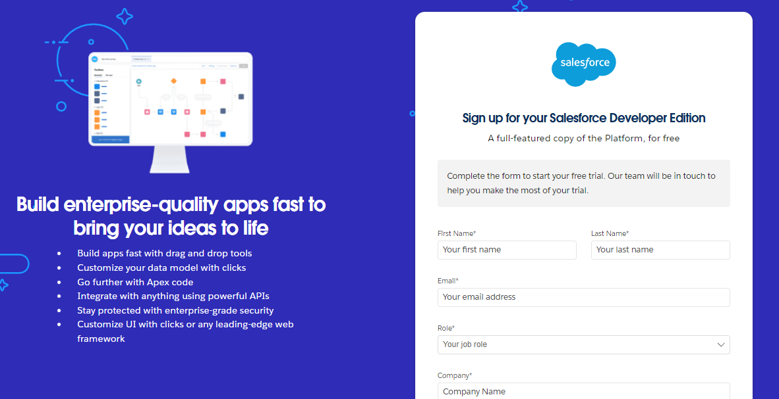](https://developers.salesforce.com/Signup*)
   1. First name & Last name: Ashni P K
   2. Email : ashnipk29@gmail.com
   3. Role : Developer
   4. Company : Anna University Regional Campus, Coimbatore.
   5. County : India
   6. Postal Code : 629151
   7. Username : ashnapk@aurcc.com

Click on sign me up after filling these.

**Account Activation**

1.Go to the inbox of the email that you used while signing up. Click on the verify account to activate your account. The email may take 5-10mins.

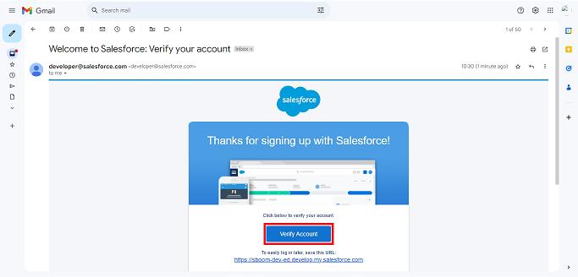

3. Click on Verify Account

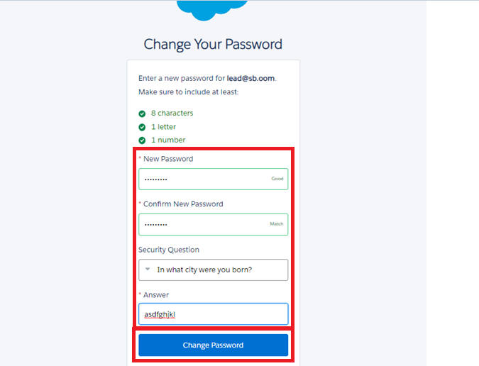4. Give a password and answer a security question and click on change password.

4.Give a password and answer a security question and click on change password.

5.Then you will redirect to your salesforce setup page.

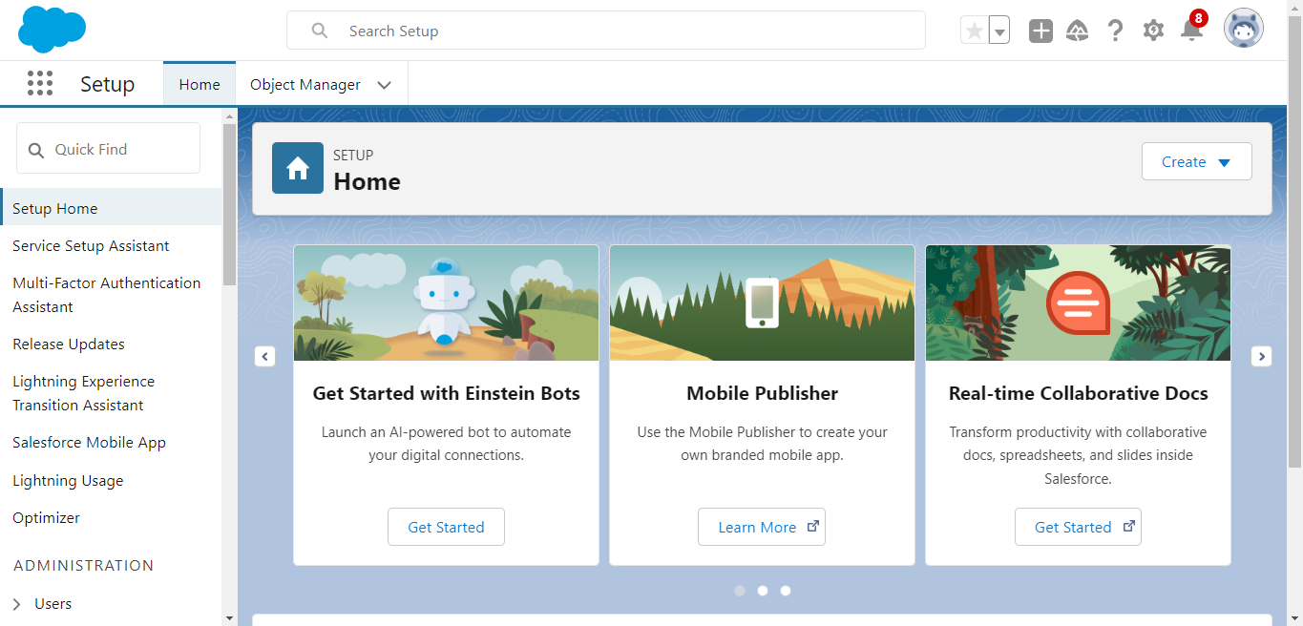

**2.Objects**

In Salesforce, an object is a database table that stores data related to a specific entity, such as customers, products, or sales transactions. Objects are the building blocks of Salesforce data models.

There are two types of objects in Salesforce:

1. **Standard Objects:** These are pre-built objects provided by Salesforce, such as Accounts, Contacts, Leads, and Opportunities, which cover common business processes.
2. **Custom Objects:** These are user-defined objects created to store data unique to a particular business or application. Custom objects can have custom fields, relationships, and custom logic through workflows and triggers.

Objects are essential for organizing and managing data within the Salesforce platform.

### Create Venue Object

To create an object:

1. From the setup page >> Click on Object Manager >> Click on Create >>Click on Custom Object.

1. Enter the label name >> Venue
2. Plural label name >> Venues
3. Enter Record Name Label and Format

* Record Name >> Venue Name
* Data Type >> Text

2. Click on Allow reports and Track Field History,Allow Activities.

3. Allow search >> Save.

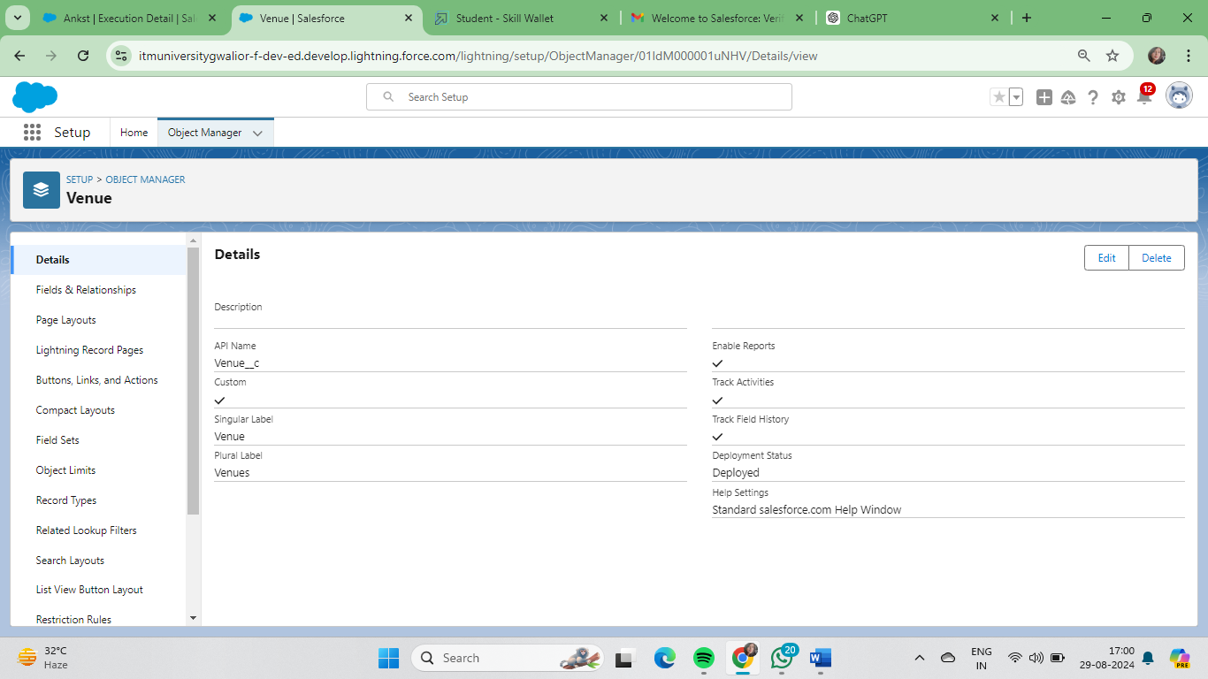

### Create Drop-Off Point Object

To create an object:

1. From the setup page >> Click on Object Manager >> Click on Create >> Click on Custom Object.

1. Enter the label name >> Drop-Off Point
2. Plural label name>> Drop-Off Points
3. Enter Record Name Label and Format

* Record Name >> Drop-Off point Name
* Data Type >> Text

2. Click on Allow reports and Track Field History,Allow Activities

3. Allow search >> Save.

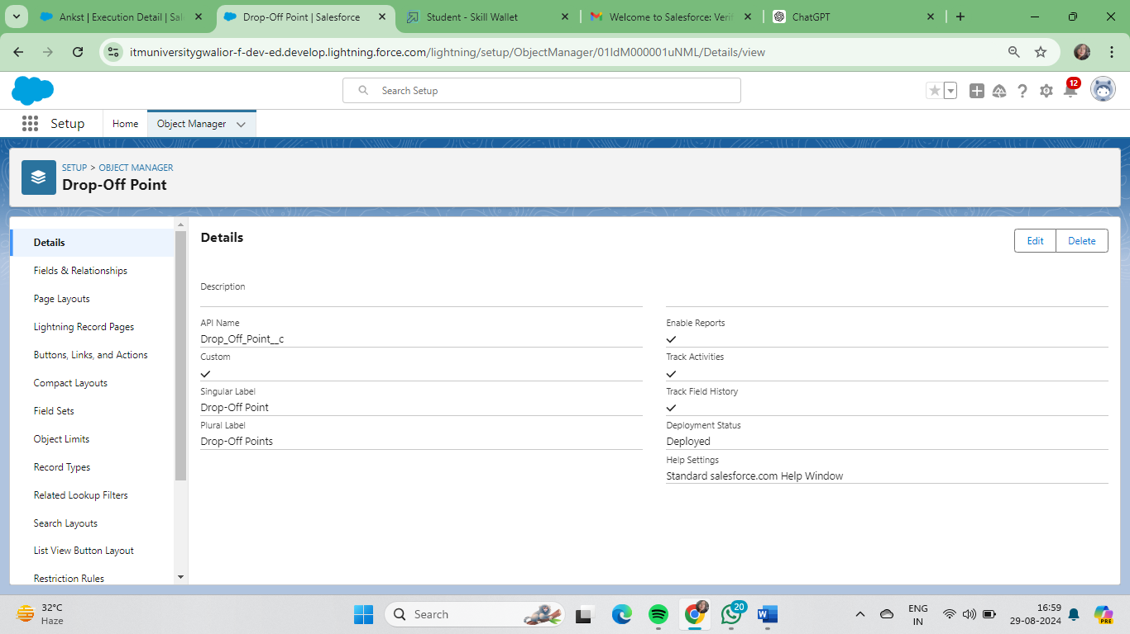

### Create Task Object:

To create an object:

1. From the setup page >> Click on Object Manager >> Click on Create >> Click on Custom Object.
2. Enter the label name>> Task
3. Plural label name>> Tasks
4. Enter Record Name Label and Format

* Record Name >> Task Name
* Data Type >> Text

2. Click on Allow reports and Track Field History,Allow Activities

3. Allow search >> Save.

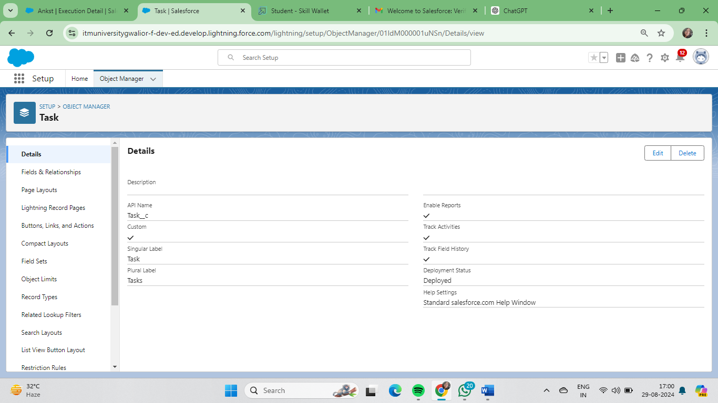

### Create Volunteer Object:

To create an object:

1. From the setup page >> Click on Object Manager>> Click on Create >> Click on Custom Object.
2. Enter the label name>> Volunteer
3. Plural label name>> Volunteers
4. Enter Record Name Label and Format

* Record Name >> Volunteer Name
* Data Type >> Text

2. Click on Allow reports and Track Field History, Allow Activities

3. Allow search >> Save.

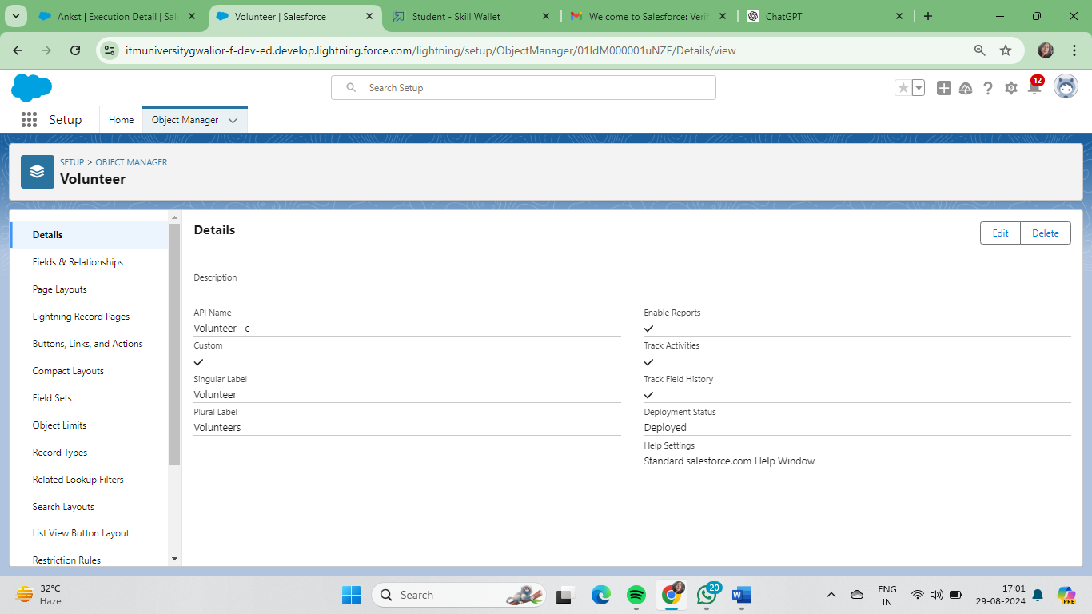

### Create Execution Details Object

To create an object:

1. From the setup page >> Click on Object Manager >> Click on Create >> Click on Custom Object.
2. Enter the label name >> Execution Detail
3. Plural label name >> Execution Details
4. Enter Record Name Label and Format

* Record Name >> Execution Detail Name
* Data Type >> Text

2. Click on Allow reports and Track Field History, Allow Activities

3. Allow search >> Save.

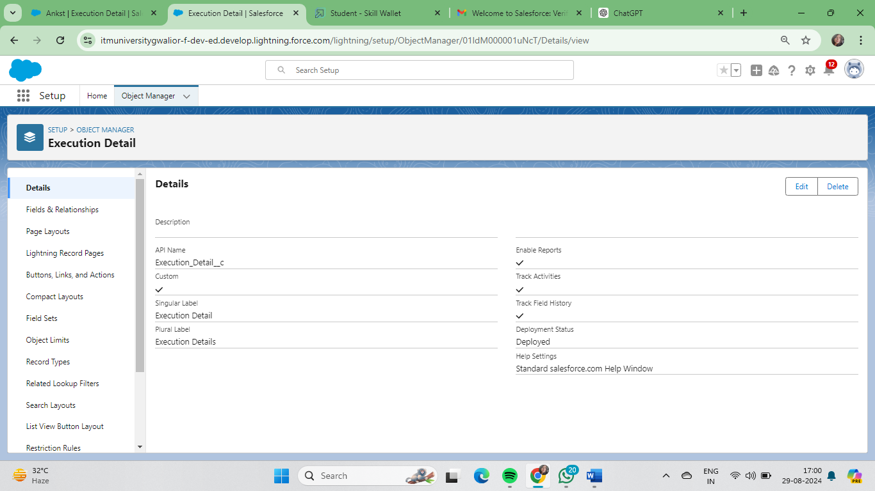

**3. Tabs**

What is Tab ?

 A tab is like a user interface that is used to build records for objects and to view the records in the objects.

### Creating A Custom Tab

To create a Tab:(Venue)

1. Go to setup page >> type Tabs in Quick Find bar >> click on tabs >> New (under custom object tab)
2. Select Object(Venue) >> Select the tab style >> Next (Add to profiles page) keep it as default >> Next (Add to Custom App)  uncheck the include tab
3. Make sure that the Append tab to users' existing personal customizations is checked.
4. Click save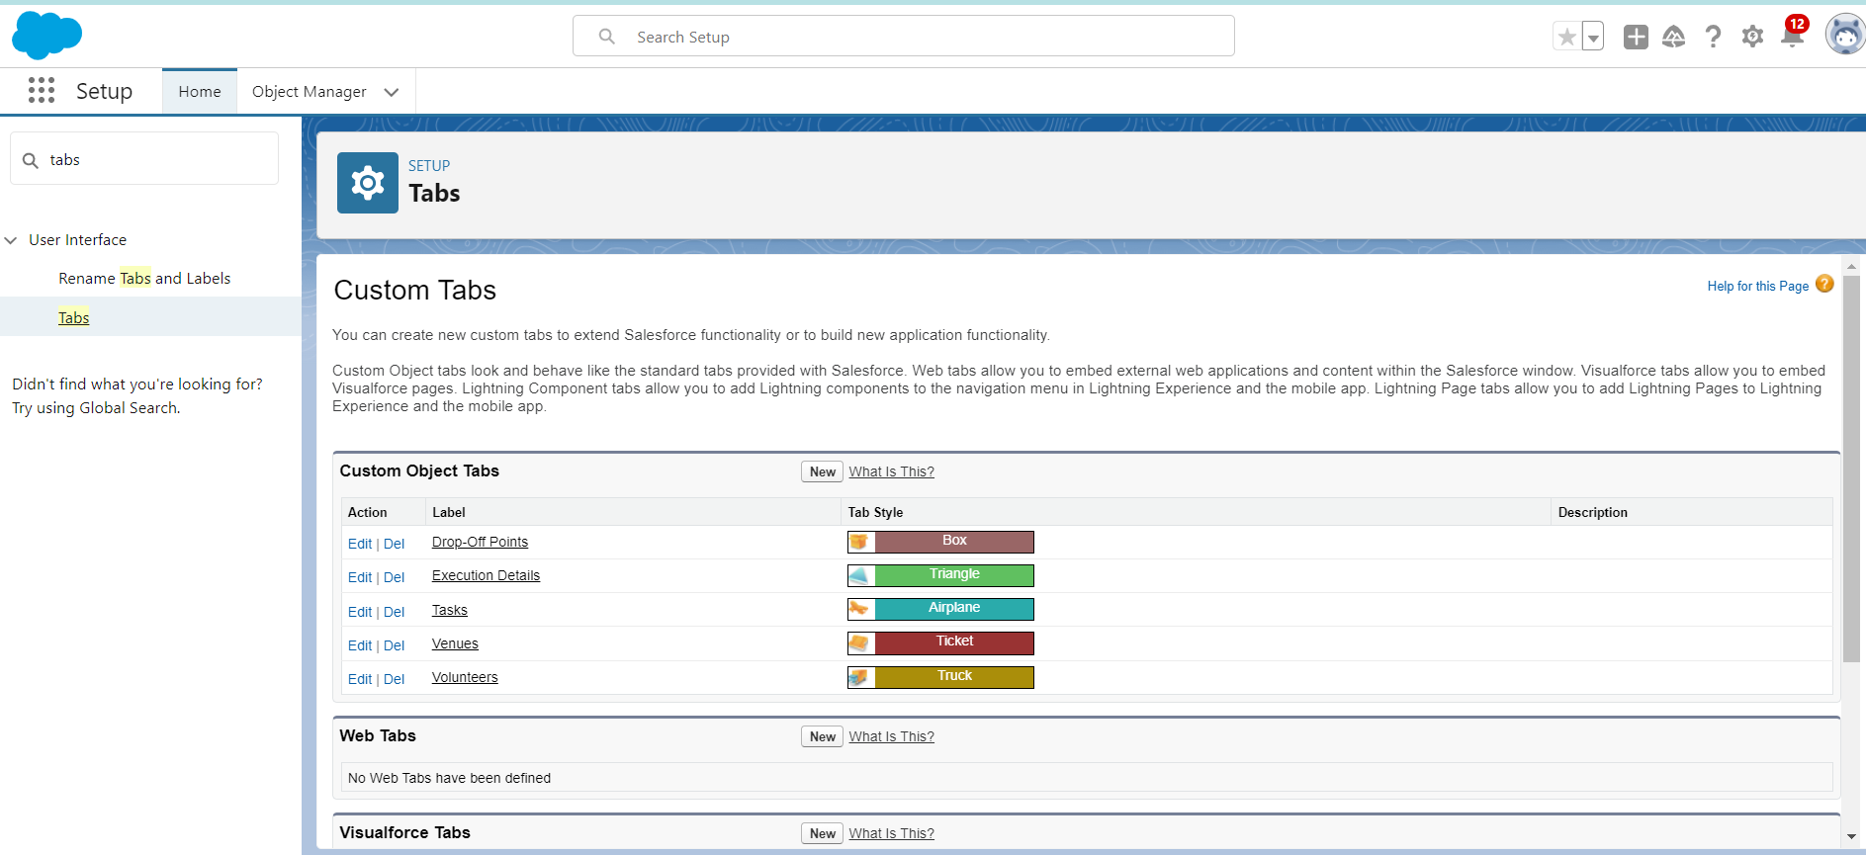

Now create the Tabs for the remaining Objects, they are “Drop-Off Point, Task, Volunteer, Execution Details.

**4. Lightning App**

**Lightning App** in Salesforce is a collection of items that work together to serve a particular function. It provides a convenient way to bundle objects, tabs, and other items into a single app, making it easier for users to access and navigate.

**To create a lightning app page:**

1. Go to setup page >> search “app manager” in quick find >> select “app manager” >> click on New lightning App.

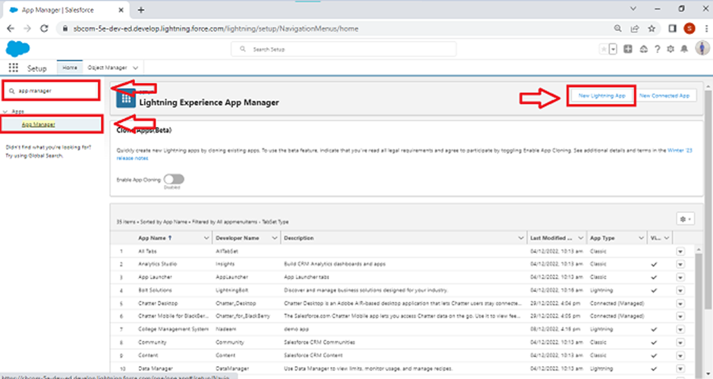

2. Fill the app name in app details and branding as follow  
App Name : FoodConnect  
Developer Name : This will auto populated  
Image : optional (if you want to give any image you can otherwise not mandatory) Primary color hex value : keep this default.

3.Then click Next  >> (App option page)Set Navigation Style as Standard Navigation >> Next.

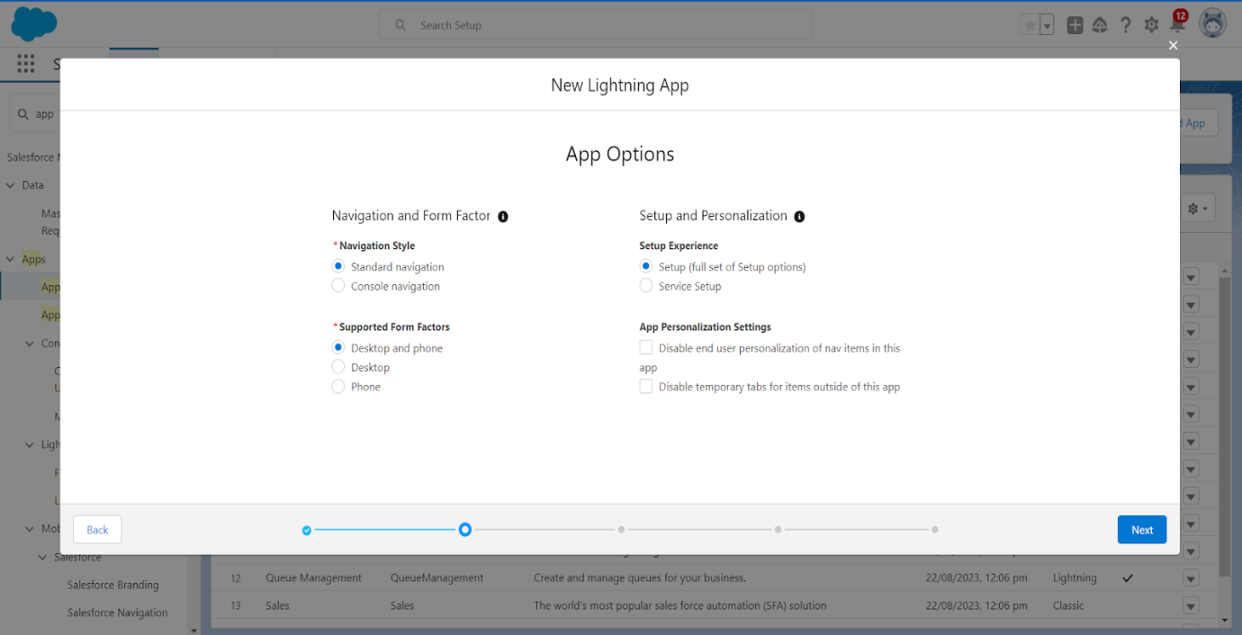

4. (Utility Items) keep it as default >> Next.  
5. To Add Navigation Items:

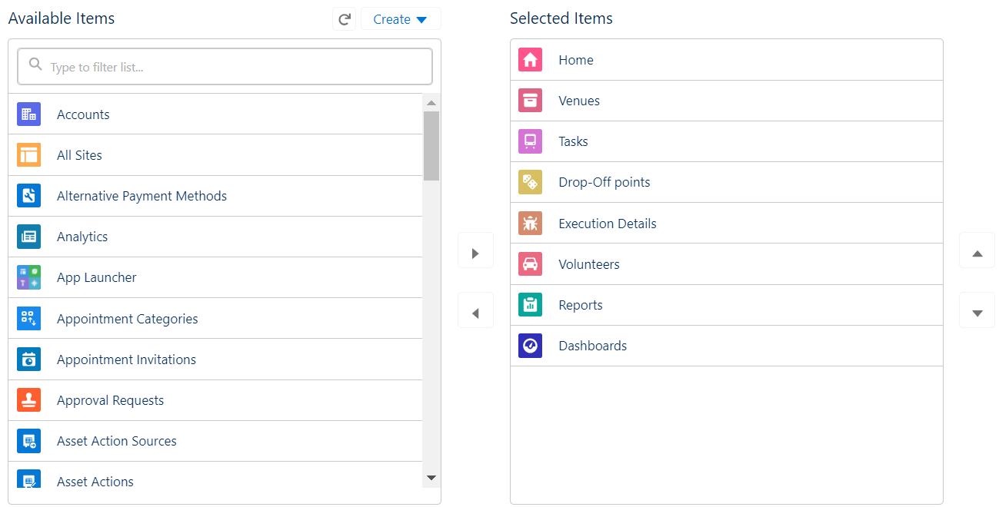

Search for the item in the (Home, Venue, Drop-Off Point, Task, Volunteer, Execution Details, Reports) from the search bar and move it using the arrow button >> Next >> Next.

6. To Add User Profiles:

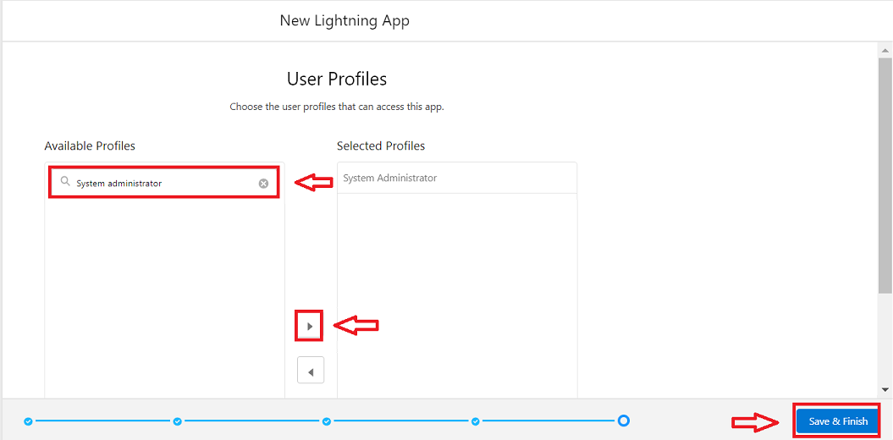

Search profiles (System administrator) in the search bar >> click on the arrow button >> save & finish.

**5. Fields**

Fields are specific data points that are used to store information within an object. Each field is a piece of data related to an object, and it has a specific data type that determines what kind of information it can hold.

### Creation of Relationship fields in objects

1. Go to setup >> click on Object Manager >> type object name(Volunteer) in the search  bar >> click on the object.
2. Now click on “Fields & Relationships” >> New
3. Select Master Detail relationship
4. Select the related object “Drop-Off point” and click next.
5. Field Name :Drop_Off_point
6. Field label : Auto generated
7. Next >> Next >> Save.

**Creation of Master Detail Relationship Field on Execution Details Object :**

1. Go to setup >> click on Object Manager >> type object name(Execution Details) in the search  bar >> click on the object.
2. Now click on “Fields & Relationships” >> New
3. Select Master Detail relationship
4. Select the related object “Volunteer” and click next.
5. Field Name : Volunteer
6. Field label : Auto generated
7. Next >> Next >> Save.

Creation of Master Detail Relationship Field on Execution Details Object :

1. Go to setup >> click on Object Manager >> type object name(Execution Details) in the search  bar >> click on the object.
2. Now click on “Fields & Relationships” >> New
3. Select Master Detail relationship
4. Select the related object “Task” and click next.
5. Field Name : Task
6. Field label : Auto generated
7. Next >> Next >> Save.

Creation of Lookup Relationship Field on Drop-Off Point Object :

1. Go to setup >> click on Object Manager >> type object name(Task) in the search  bar >> click on the object.
2. Now click on “Fields & Relationships” >> New
3. Select Lookup relationship
4. Select the related object “Drop-Off Point” and click next.
5. Field Name : Venue
6. Field label :Venue__c
7. Next >> Next >> Save.

Creation of Lookup Relationship Field on Task Object :

1. Go to setup>> click on Object Manager >> type object name(Task) in the search  bar >> click on the object.
2. Now click on “Fields & Relationships” >> New
3. Select Lookup relationship
4. Select the related object “Venue” and click next.
5. Field Name : Sponsored By
6. Field label : Auto generated
7. Next >> Next >> Save.

Creation of Lookup Relationship Field on Task Object :

1. Go to setup>> click on Object Manager >> type object name(Task) in the search  bar >> click on the object.
2. Now click on “Fields & Relationships” >> New
3. Select Lookup relationship
4. Select the related object “Drop-Off point” and click next.
5. Field Name : Drop-Off point
6. Field label : Auto generated
7. Next >> Next >> Save.

**Creation Of Fields For The Venue Object:**

1. Go to setup>> click on Object Manager >> type object name(Venue) in search bar >> click on the object.
2. Now click on “Fields & Relationships” >> New
3. Select Data type as a “Email” and Click on Next
4. Fill the Above as following:

* Field Label : Contact Email
* Field Name : Contact Email
* Click on required check box
* Click on Next >> Next >> Save and new.

**To create another fields in an object:**

5. Go to setup >> click on Object Manager >> type object name(Venue) in search bar >> click on the object.

6. Now click on “Fields & Relationships” >> New

7. Select Data type as a “Phone” and Click on Next

8. Fill the Above as following:

* Field Label : Contact Phone
* Field Name : Contact Phone
* Click on required check box
* Click on Next >> Next >> Save and new.

**To create another fields in an object:**

1. Go to setup >> click on Object Manager >> type object name(Venue) in search bar >>click on the object.
2. Now click on “Fields & Relationships” >> New
3. Select Data type as a “Geolocation” and Click on Next
4. Fill the Above as following:

* Field Label : Location
* Decimal Places : 4
* Field Name : Location
* Description : Enter the Geolocation of your Venue
* Click on Next >> Next >> Save and new.

To create another fields in an object:

5. Go to setup >> click on Object Manager >> type object name(Venue) in search bar >> click on the object.

6. Now click on “Fields & Relationships” >> New

7. Select Data type as a “Long Text Area” and Click on Next

8. Fill the Above as following:

* Field Label : Venue Location
* Field Name :Venue_Location
* Click on Next >> Next >> Save and new.

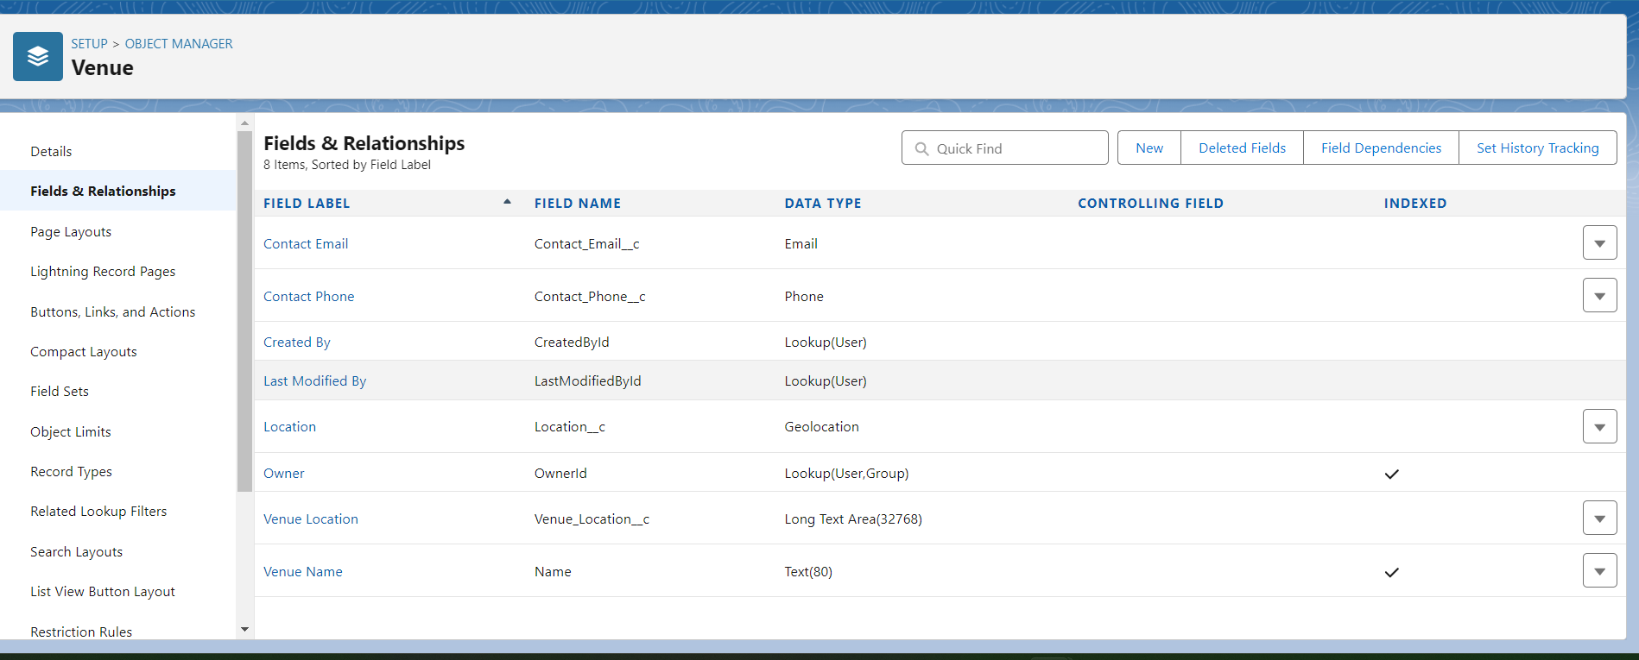

**Creation Of Fields For The Drop-Off Point Object**

1. Go to setup >> click on Object Manager >> type object name(Drop-Off point) in search bar >> click on the object.

2. Now click on “Fields & Relationships” >> New

3. Select Data type as a “Geolocation” and Click on Next

4. Fill the Above as following:

* Field Label : Location 2
* Field Name : gets auto generated
* Description : Enter the Geolocation of the Drop off Point
* Geolocation Options : select Decimal
* Decimal Places : 4
* Click on Next >> Next >> Save and new.

To create another fields in an object:

1. Go to setup >> click on Object Manager >> type object name(Drop-Off point) in search bar >> click on the object.
2. Now click on “Fields & Relationships” >> New
3. Select Data type as a “Formula” and Click on Next
4. Fill the Above as following:

* Field Label : distance calculation
* Field Name :distance_calculation
* Formula Return Type : Number
* Formula Options : DISTANCE( Location_2__c ,  Venue__r.Location__c , 'km')
* Click on Next >> Next >> Save and new

To create another fields in an object:

1. Go to setup >> click on Object Manager >> type object name(Drop-Off point) in search bar >> click on the object.
2. Now click on “Fields & Relationships” >> New
3. Select Data type as a “Picklist” and Click on Next

Fill the Above as following:

* Field Label : State
* Field Name : State
* Enter values, with each value separated by a new line :

Andhra Pradesh

Arunachal Pradesh

Assam

Bihar

Chhattisgarh

Goa

Gujarat

Haryana

Himachal Pradesh

Jharkhand

Karnataka

Kerala

Maharashtra

Madhya Pradesh

Manipur

Meghalaya

Mizoram

Nagaland

Odisha

Punjab

Rajasthan

Sikkim

Tamil Nadu

Tripura

Telangana

Uttar Pradesh

Uttarakhand

West Bengal

Andaman & Nicobar (UT)

Chandigarh (UT)

Dadra & Nagar Haveli and Daman & Diu (UT)

Delhi [National Capital Territory (NCT)]

Jammu & Kashmir (UT)

Ladakh (UT)

Lakshadweep (UT)

Puducherry (UT)

* Click on required check box
* Click on Next >> Next >> Save and new.

To create another fields in an object:

8. Go to setup >> click on Object Manager >> type object name(Task) in search bar >> click on the object.

9.Now click on “Fields & Relationships” >> New

10. Select Data type as a “Number” and Click on Next

11. Fill the Above as following:

* Field Label : Distance
* Field Name : Distance
* Length : 14
* Decimal Places : 4
* Click on required check box
* Click on Next >> Next >> Save and new.

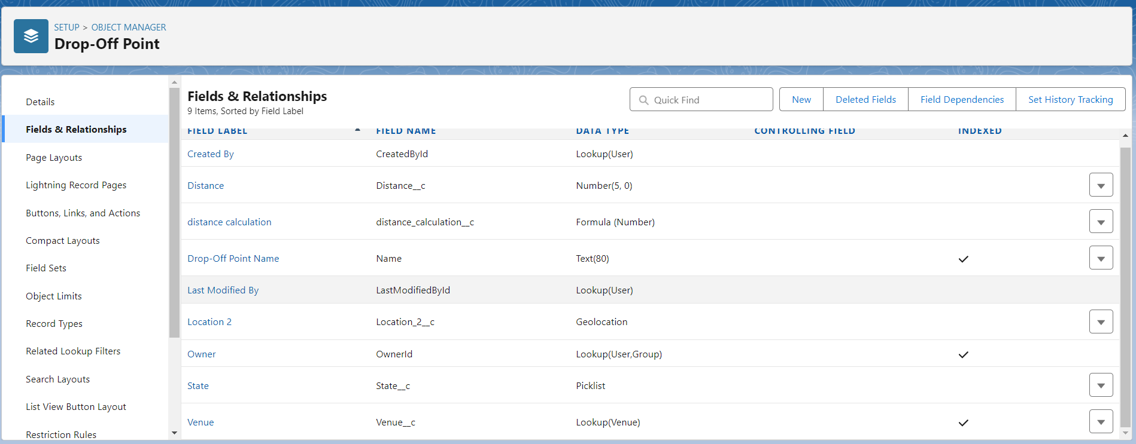

**Creation Of Fields For The Task Object:**

1.Go to setup>> click on Object Manager >> type object name(Task) in search bar >> click on the object.

2. Now click on “Fields & Relationships” >> New

3. Select Data type as a “Auto Number” and Click on Next

4. Fill the Above as following:

* Field Label : Task ID
* Display Format : TASK-{0}
* Starting Number : 1
* Field Name : gets auto generated
* Click on required check box
* Click on Next >> Next >> Save and new.

To create another fields in an object:

1. Go to setup >> click on Object Manager >> type object name(Task) in search bar >> click on the object.
2. Now click on “Fields & Relationships” >> New
3. Select Data type as a “Date” and Click on Next
4. Fill the Above as following:

* Field Label : Date
* Field Name : Date
* Click on required check box
* Click on Next >> Next >> Save and new.

To create another fields in an object:

5. Go to setup >> click on Object Manager >> type object name(Task) in search bar >> click on the object.

6. Now click on “Fields & Relationships” >> New

7. Select Data type as a “Picklist (Multi-Select)” and Click on Next

Fill the Above as following:

* Field Label : Food Category
* Field Name : Food Category
* Enter values, with each value separated by a new line :

Veg

Non-Veg

Salad

Snack

* Click on required check box
* Click on Next >> Next >> Save and new.

To create another fields in an object:

8. Go to setup >> click on Object Manager >> type object name(Task) in search bar >> click on the object.

9. Now click on “Fields & Relationships” >> New

10.Select Data type as a “Number” and Click on Next

11. Fill the Above as following:

* Field Label : Number of People Served
* Field Name :Number_of_People_Served
* Click on required check box
* Click on Next >> Next >> Save and new.

To create another fields in an object:

12. Go to setup >> click on Object Manager >> type object name(Task) in search bar >> click on the object.

14. Now click on “Fields & Relationships” >> New

15. Select Data type as a “Text” and Click on Next

16. Fill the Above as following:

* Field Label : Name of the Person
* Field Name :Name_of_the_Person
* Click on Next >> Next >> Save and new.

To create another fields in an object:

17. Go to setup>> click on Object Manager >> type object name(Task) in search bar >> click on the object.

18. Now click on “Fields & Relationships” >> New

19. Select Data type as a “Phone” and Click on Next

20. Fill the Above as following:

* Field Label : Phone
* Field Name : Phone
* Click on Next >> Next>> Save and new.

To create another fields in an object:

21. Go to setup >> click on Object Manager >> type object name(Task) in search bar >> click on the object.

22. Now click on “Fields & Relationships” >> New

23. Select Data type as a “Pick List” and Click on Next

24. Fill the Above as following:

* Field Label : Rating
* Field Name : Rating
* Enter values, with each value separated by a new line :

1

2

3

4

5

* Click on Next >> Next >> Save and new.

To create another fields in an object:

25. Go to setup >> click on Object Manager >> type object name(Task) in search bar >> click on the object.

26. Now click on “Fields & Relationships” >> New

27. Select Data type as a “Long Text Area” and Click on Next

28. Fill the Above as following:

* Field Label : Feedback
* Field Name : Feedback
* Click on Next >> Next >> Save and new.

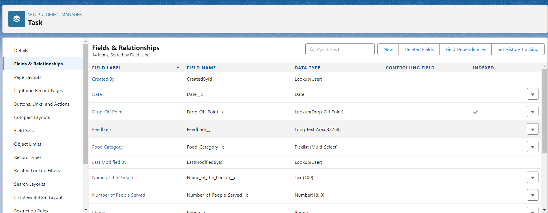

**Creation Of Fields For The Volunteer Object**

1. Go to setup >> click on Object Manager >> type object name(Volunteer) in search bar >> click on the object.

2. Now click on “Fields & Relationships” >> New

3. Select Data type as a “Auto Number” and Click on Next

4. Fill the Above as following:

* Field Label : Volunteer ID
* Field Name : gets auto generated
* Click on required check box
* Click on Next >> Next >> Save and new.
* Click on Next >> Next >> Save and new.

To create another fields in an object:

1. Go to setup >> click on Object Manager >> type object name(Volunteer) in search bar >> click on the object.
2. Now click on “Fields & Relationships” >> New
3. Select Data type as a “Picklist” and Click on Next
4. Fill the Above as following:

* Field Label : Gender
* Field Name : Gender
* Enter values, with each value separated by a new line :

Female

Male

* Click on Next >> Next >> Save and new.

To create another fields in an object:

5. Go to setup >> click on Object Manager >> type object name(Volunteer) in search bar >> click on the object.

6. Now click on “Fields & Relationships” >> New

7. Select Data type as a “Date” and Click on Next

8. Fill the Above as following:

* Field Label : Available On
* Field Name : Available On
* Click on required check box
* Click on Next >> Next >> Save and new.

To create another fields in an object:

9. Go to setup >> click on Object Manager >> type object name(Volunteer) in search bar >> click on the object.

10. Now click on “Fields & Relationships” >> New

11. Select Data type as a “Number” and Click on Next

12. Fill the Above as following:

* Field Label : Age
* Field Name : Age
* Click on required check box
* Click on Next >> Next>> Save and new.

To create another fields in an object:

13. Go to setup >> click on Object Manager >> type object name(Volunteer) in search bar >> click on the object.

14.Now click on “Fields & Relationships” >> New

15.Select Data type as a “Email” and Click on Next

16. Fill the Above as following:

* Field Label : Email
* Field Name : Email
* Click on required check box
* Click on Next>> Next >> Save and new.

To create another fields in an object:

17. Go to setup >> click on Object Manager >> type object name(Volunteer) in search bar >> click on the object.

18. Now click on “Fields & Relationships” >> New

19. Select Data type as a “Number” and Click on Next

20. Fill the Above as following:

* Field Label : Contact Number
* Field Name :Contact_Number
* Click on required check box
* Click on Next >> Next >> Save and new.

To create another fields in an object:

21. Go to setup >> click on Object Manager >> type object name(Volunteer) in search bar >> click on the object.

22. Now click on “Fields & Relationships” >> New

23. Select Data type as a “Text Area (Long)” and Click on Next

24. Fill the Above as following:

* Field Label : Address
* Field Name : Address
* Click on Next >> Next >> Save and new.

To create another fields in an object:

25. Go to setup >> click on Object Manager >> type object name(Volunteer) in search bar >> click on the object.

26. Now click on “Fields & Relationships” >> New

27. Select Data type as a “Date” and Click on Next

28. Fill the Above as following:

* Field Label : Date of Birth
* Field Name :Date_of_Birth
* Click on Next >> Next >> Save and new.

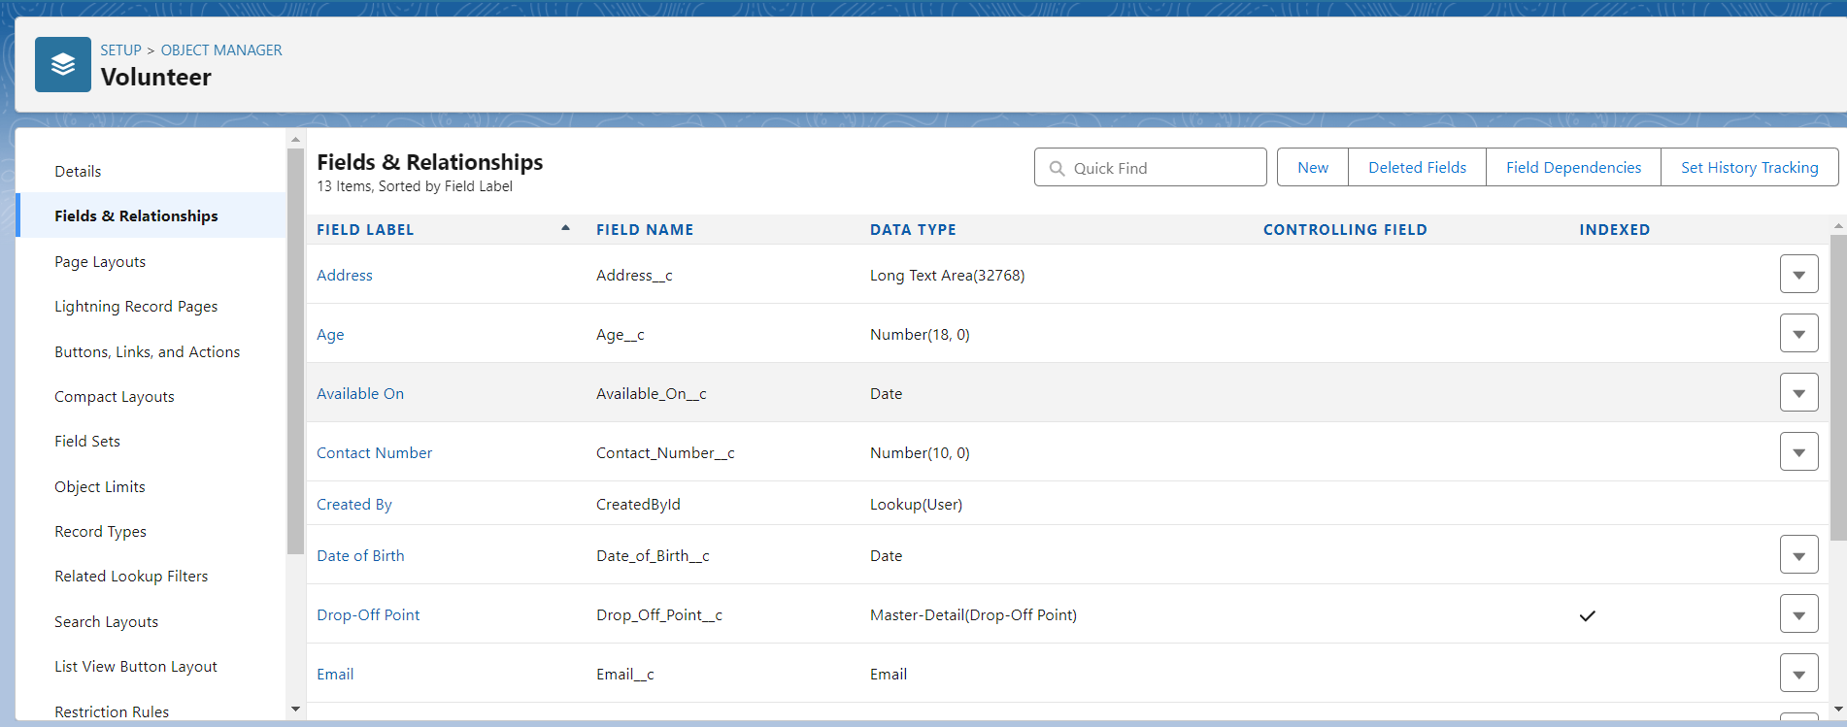

### Creation Of Fields For The Execution Details Object

1.Go to setup >> click on Object Manager >> type object name(Volunteer) in search bar >> click on the object.

2. Now click on “Fields & Relationships” >> New

3. Select Data type as a “Auto Number” and Click on Next

4. Fill the Above as following:

* Field Label : Execution ID
* Field Name : gets auto generated
* Click on required check box
* Click on Next >> Next >> Save and new.

**6. Flow**

**Flow** is an application that automates complex business processes. Using Flows, you can collect, update, and create Salesforce records, as well as display information to users. They are part of Salesforce's declarative automation tools, which means you can create and manage them without writing a single line of code.

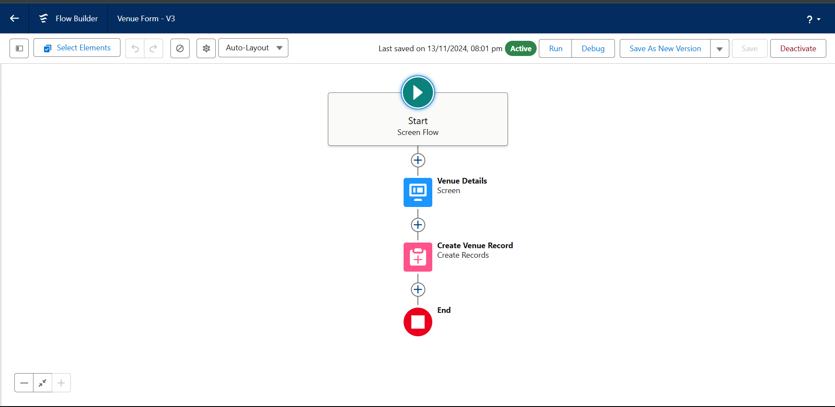

**7. Trigger**

T**rigger** is a piece of Apex code that executes before or after specific data manipulation events occur on a record, such as insert, update, delete, or undelete. Triggers are used to perform custom actions and automate processes based on changes to Salesforce records.

### Trigger code

**Code:**

trigger DropOffTrigger on Drop_Off_point__c (before insert) {

    for(Drop_Off_point__c Drop : Trigger.new){

        Drop.Distance__c = Drop.distance_calculation__c;

    }

}

**8. Creation of Users**

To create a user:

1. Go to setup page >> type users in Quick Find bar >> click on users>> New user.
2. In General Information give details as: (Note : create users as per your wish NGO’s)

First Name : Iksha Foundation

Last Name : Iksha_Foundation

Alias : iiksh

Email : Give Your Email

Username : [ikshafoundation@sb.com](mailto:ikshafoundation@sb.com) (give the username different)

Nickname : Auto Populated

User License : Salesforce Platform

Profile : NGOs Profile

Active : Check

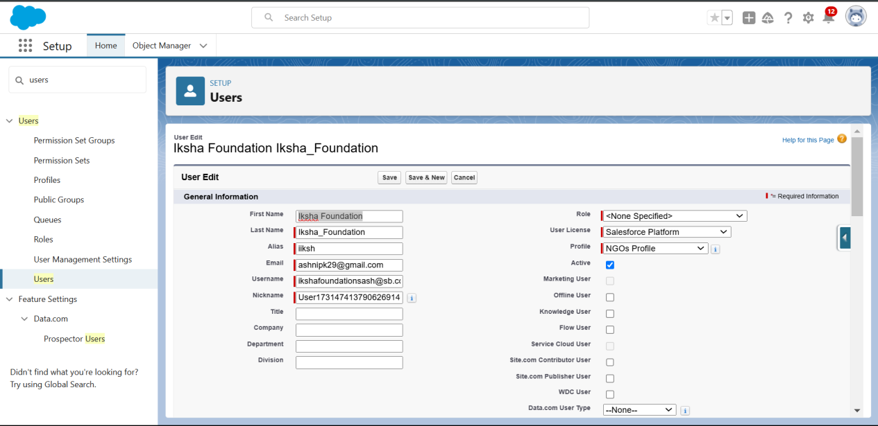

**9. Public Group**

**Public Group** is a collection of users that can be used to streamline sharing and collaboration within the platform. Public Groups can include individual users, other groups, roles, or territories, and they are primarily used for security and access control.

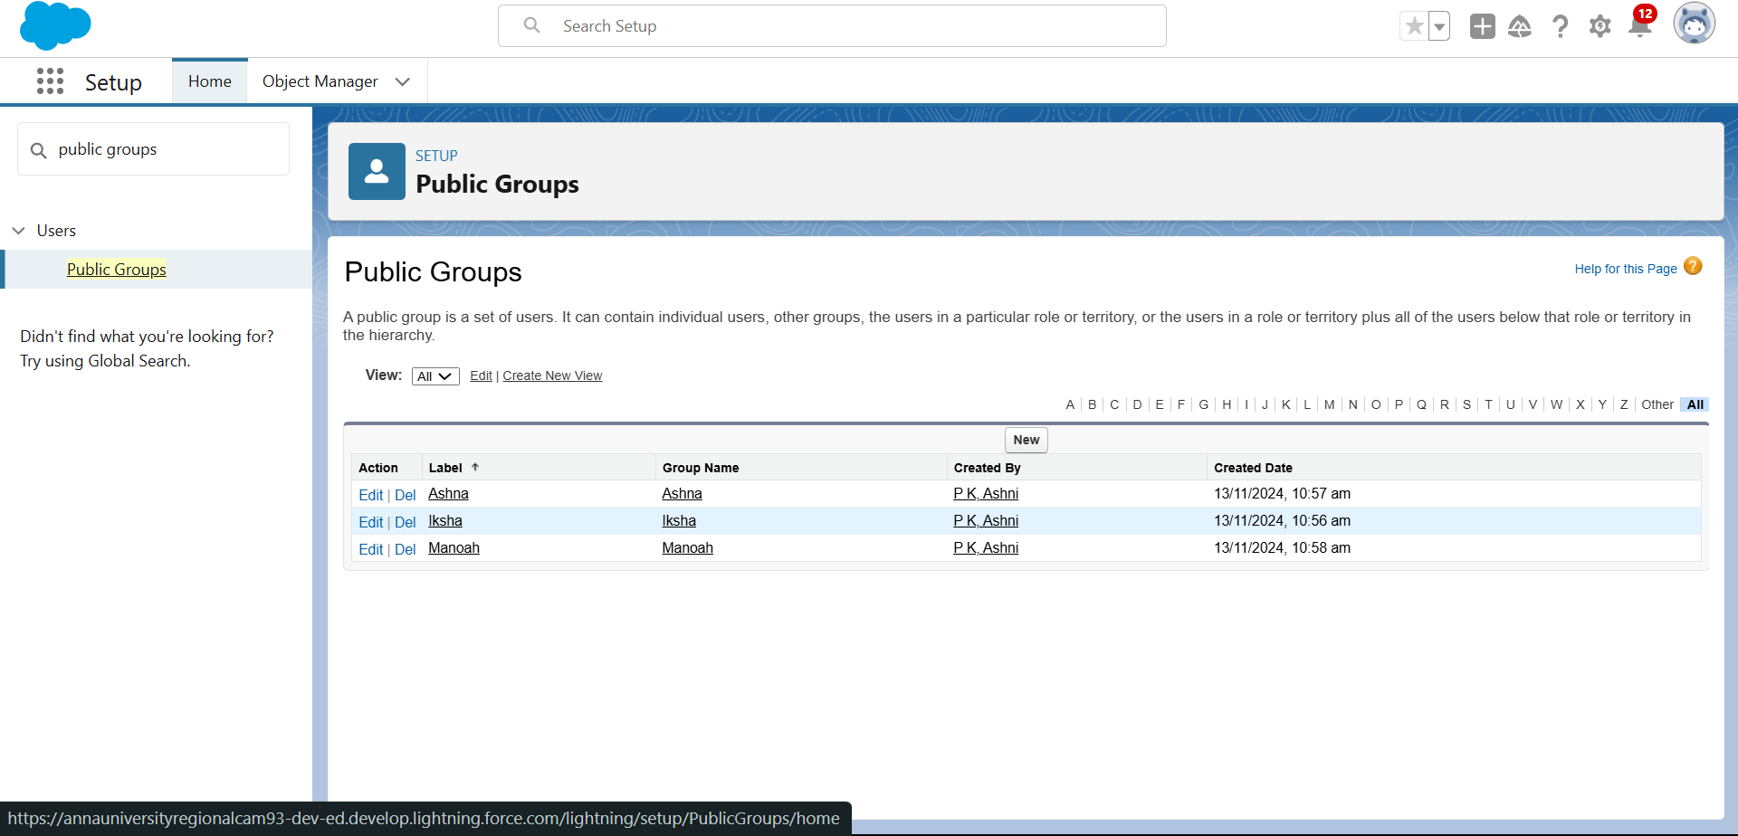

**10. Report Type**

**Report Types** are templates that determine which records and fields are available for use when creating a report. They define the relationships between the objects in your report and ensure that you have access to the necessary data.

To create a report type

* Go to setup page  >>  type Report Types in Quick Find bar  >> click on Report Types  >>  click on Continue   >>  Click on New Custom Report Type.
* In Define the Custom Report Type:
* Primary Object : Select Venues
* Report Type Label : Venue with DropOff with Volunteer
* Report Type Name : Venue_with_DropOff_with_Volunteer
* Description : Venue with DropOff with Volunteer
* Store in Category : Select Other Reports
* Deployment Status : Deployed
* Click on Next
* Near Click to relate another Object Select Drop-Off Points.
* And also select "A" records may or may not have related "B" records.
* Now again Near Click to relate another Object Select Volunteers.

1. Now click on Save.

**11. Reports**

**Reports** are powerful tools that allow you to analyze and present data stored within your organization. They provide insights into your business processes and help you make informed decisions.

### Creation of Report on Venue with DropOff with Volunteer

* Go to the app(FoodConnect)  >>  click on the reports tab
* Click on New Folder.
  + - Folder Label : Custom Reports
    - Folder Unique Name : CustomReports
* Open Custom Reports and click on New Report
* Select Report Type : Venue with DropOff with Volunteer
* Then click on Start Report.
* In GROUP ROWS : Add Volunteer Name
* In Columns : Add Venue Name, Drop-Off point Name, Distance.

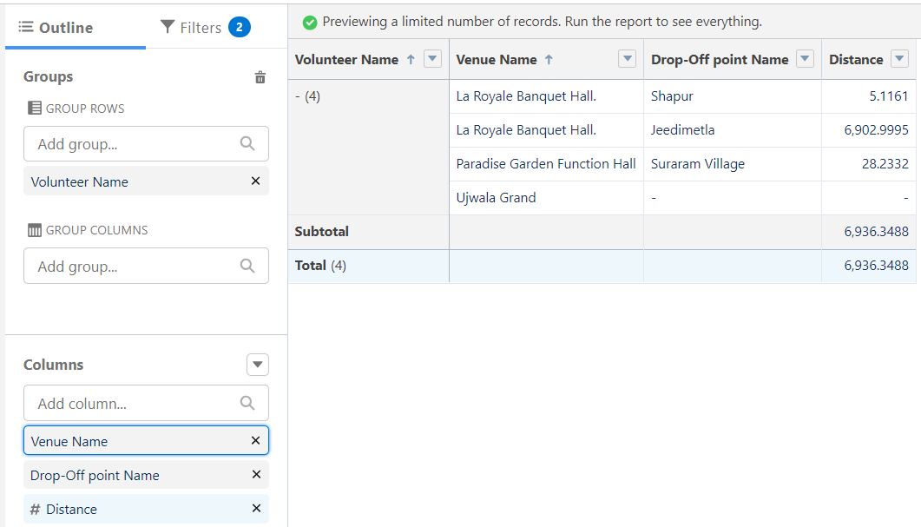

* Now click on Save & Run.
* Give Label as :
* Report Name : venue and Drop Off point
* Report Unique Name : Auto Populated
* Click on Select Folder and select Custom Report, then click on Save.

**12. Dashboards**

**Dashboards** are powerful tools that provide a visual representation of your reports. They help you monitor business performance, analyze data trends, and make informed decisions. Dashboards are composed of multiple components, each displaying data from different reports in various formats such as charts, graphs, and tables.

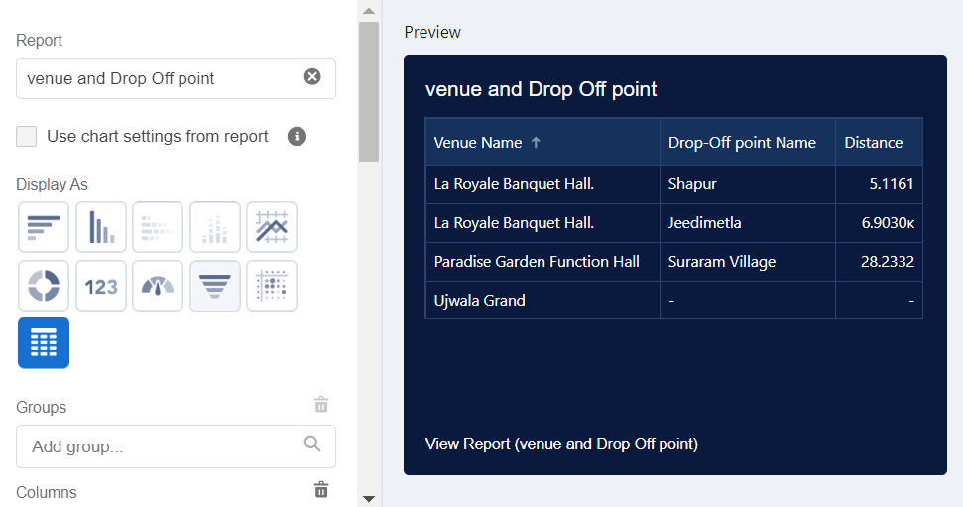

**13. Sharing Rules**

**Sharing Rules** in Salesforce are a powerful tool used to extend sharing access to users in public groups, roles, or territories. They provide additional permissions beyond those set by the organization-wide defaults, role hierarchies, and sharing settings.

### Creation of sharing rules

* Go to setup  >>  type Sharing Settings in quick find box  >>  Click on the Sharing Settings.
* Scroll down and find Drop-Off point Sharing Rules.
* Click on new near Drop-Off point Sharing Rules and Name it as:
  + - Label : Rule 1
    - Rule Name : Rule_1
* Select your rule type : Select Based on criteria.
* Select which records to be shared:
  + - Field : Operator : Value = Distance : less than : 15
* Select the users to share with : Near Share With
  + - Public Groups : Iksha
* Click on Save.
* Click on new near Drop-Off point Sharing Rules and Name it as:
  + - Label : Rule 2
    - Rule Name : Rule_2
* Select your rule type : Select Based on criteria.
* Select which records to be shared:
* Field : Operator : Value = Distance : greater than : 15
* Field : Operator : Value = Distance : less or equal : 30
* Select the users to share with : Near Share With
  + - Public Groups : NSS
* Click on Save.
* Click on new near Drop-Off point Sharing Rules and Name it as:
  + - Label : Rule 3
    - Rule Name : Rule_3
* Select your rule type : Select Based on criteria.
* Select which records to be shared:
  + - Field : Operator : Value = Distance : greater than : 30
    - Field : Operator : Value = Distance : less or equal : 50
* Select the users to share with : Near Share With
  + - Public Groups : Street Cause
* Click on Save.

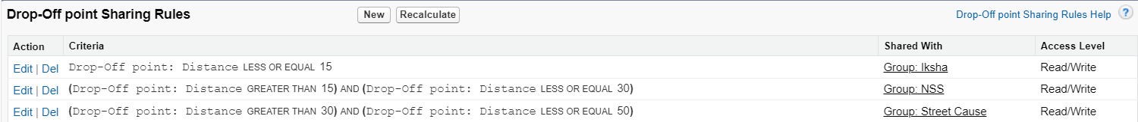

**14. Home Page**

### Creation of Home Page

* Go to setup >> type Lightning App Builder in quick find box  >>  Click on the Lightning App Builder and Select the New.
* Select Home Page and give Label as HOME Page.
* Select Standard Home Page.
* Near Components search for Flow and Drag and Drop in Right Side Section..
* On the right hand side:
  + - Flow : Venue Flow
* Near Components search for Dashboard, then Drag and Drop it in first Section.
* Click on Save and Activation, then click on App Default, then Add Assignments.
* Add FoodConnect App and then Save.
* FoodConnect Home Page would Look Like this.

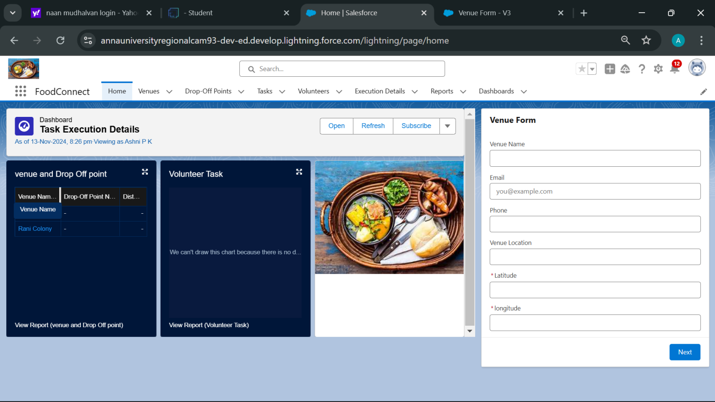

Conclusion for my food connect project

### ****5. Conclusion****

The **Food Connect** project leverages Salesforce to tackle the pressing issues of food waste and hunger. By creating an efficient system that connects food donors with volunteers and beneficiaries, this initiative aims to ensure that surplus food is utilized effectively to support underprivileged communities.

### ****Key Achievements****

* **Efficient Processes**: Streamlined food collection, storage, and distribution processes through automated workflows and real-time data tracking.
* **Enhanced Collaboration**: Improved coordination among donors, volunteers, and beneficiaries, fostering a sense of community and shared responsibility.
* **Significant Impact**: Reduced food waste and provided essential support to those in need, contributing to a more sustainable and equitable society.